Social Media Marketing

Assignment

How to run a Facebook ad campaign

Done by

Abrar ali

BBA(IT)III

121418408020

Step 1:Create a Facebook page

Log in to your Facebook account and click on the **create menu**(+sign) and click on **page**.

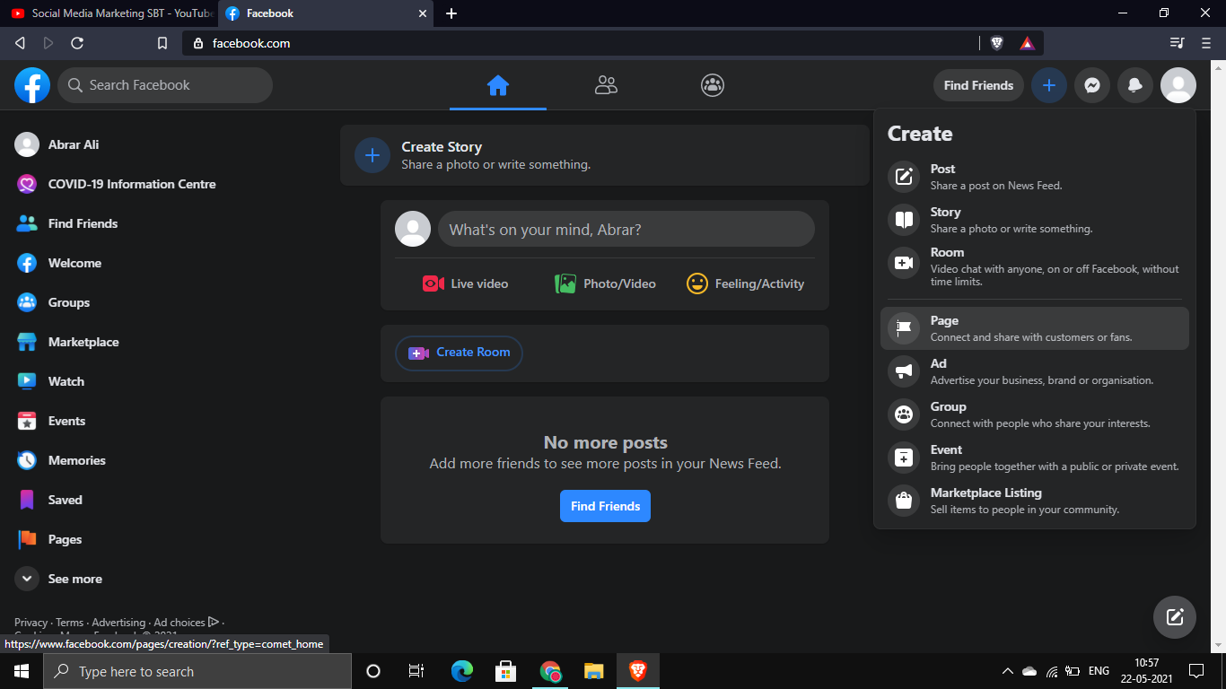

Step 1 b)Enter information about the page

Enter the page name, the category it falls in, and a small description of the page and then insert the profile picture of your business and a cover page.

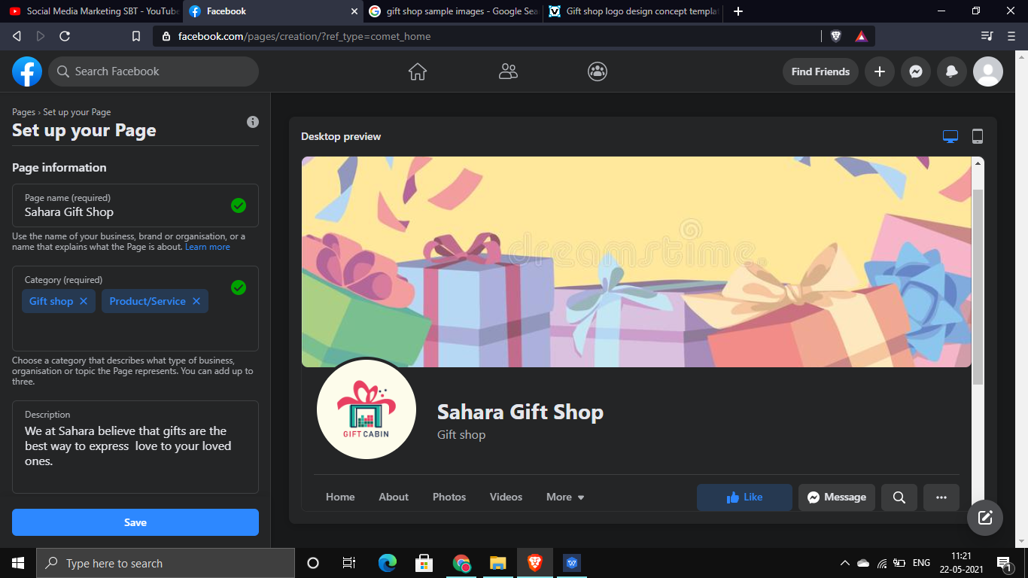

Step 2: Promotion

After creating your page, go to your profile and click on **promote**.

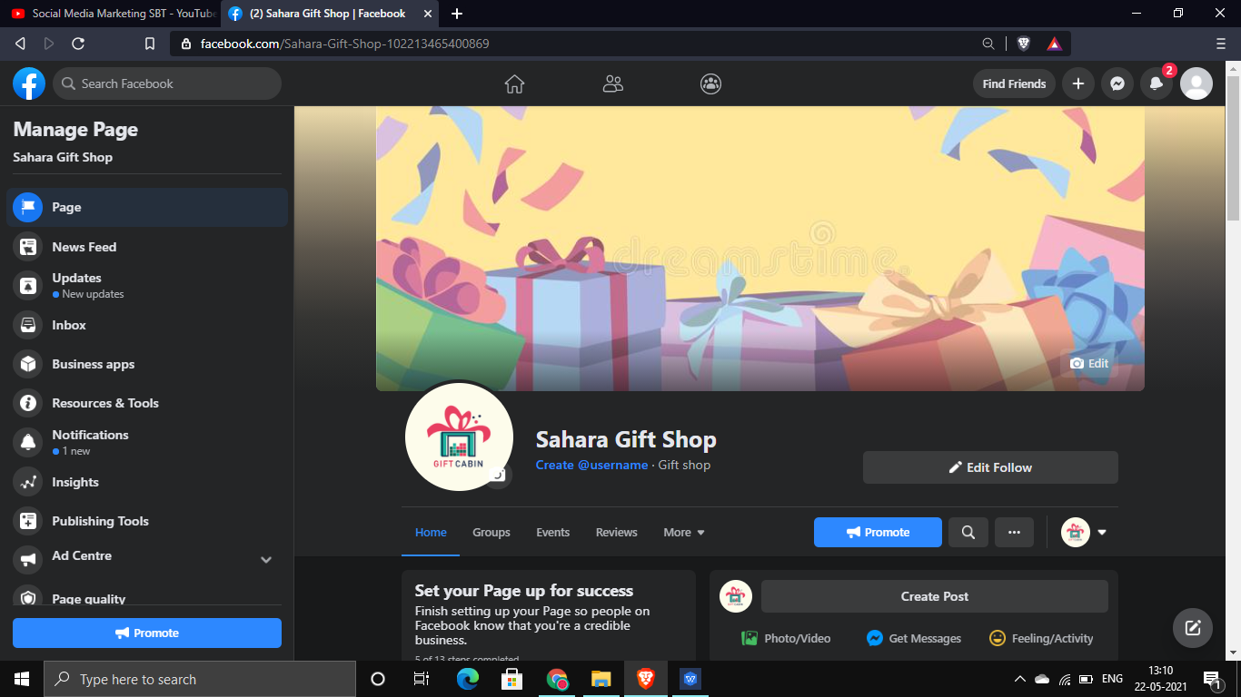

Step 2 b) Choose a Goal

You will be directed to this screen, choose what is the goal of your promotion. It can be to a) to promote your page b) to get more website visitors c) to get more leads or d) to get more messages

Since the page is brand new it is **advisable to promote your page** first

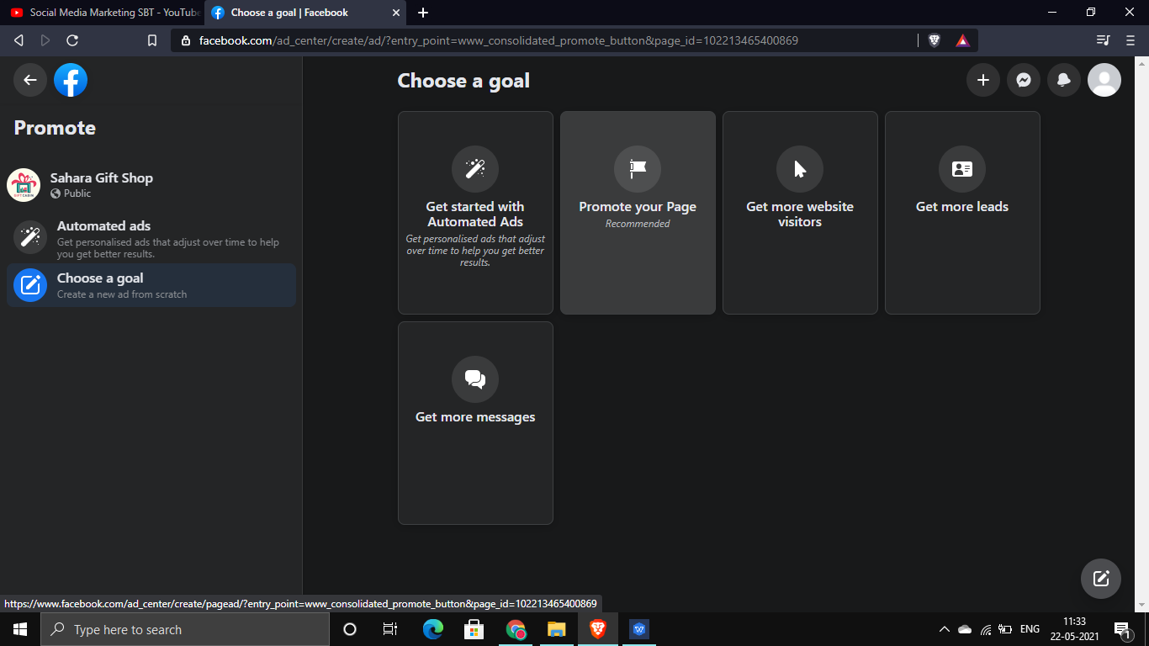

You will be presented with an **AD preview**. The ad preview will show us how the ad will look to the target audience.

Ad preview for desktop:

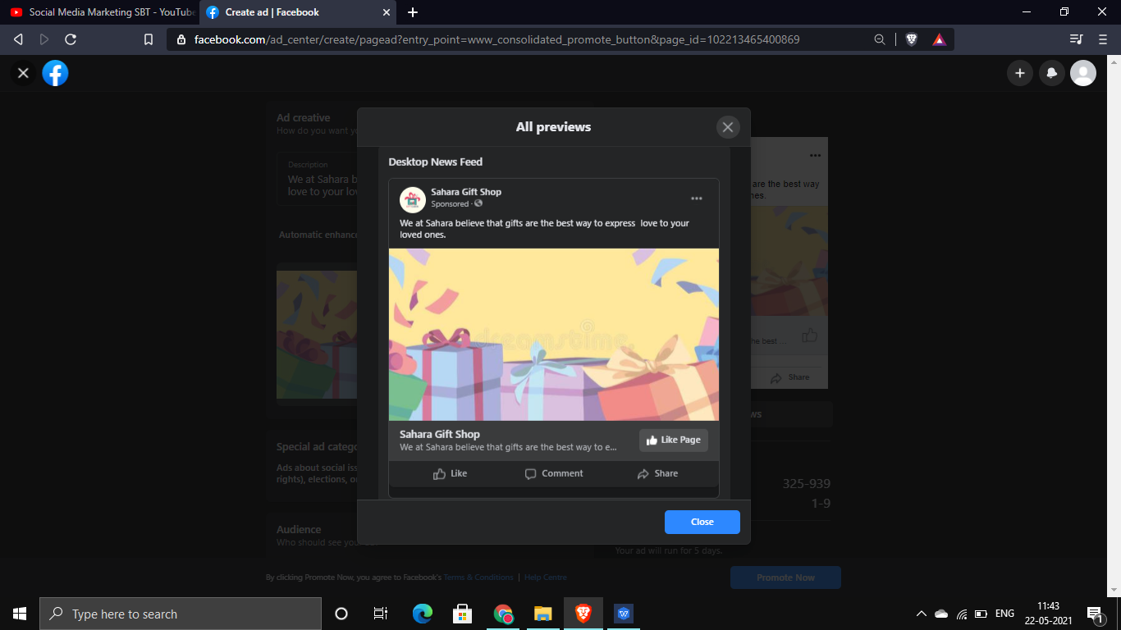

Ad preview for mobile users:

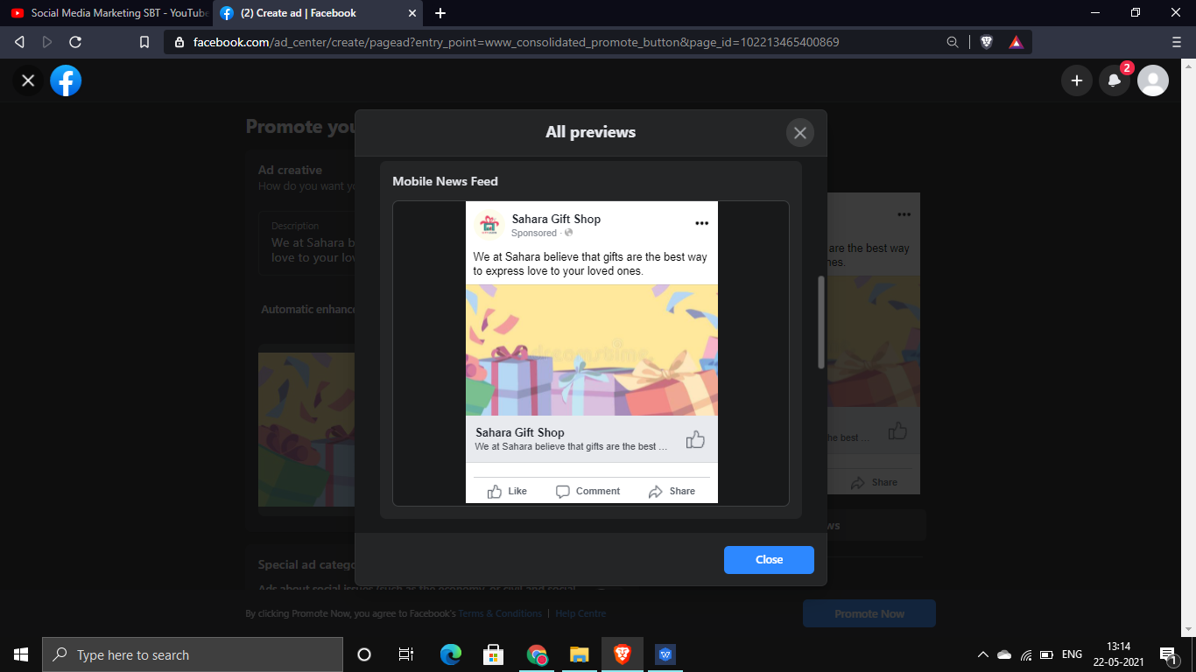

Step 3) Ad targeting

In this section, we will define the target audience of your advertisement.

Advertisement can be targeted based on location, gender and age group.

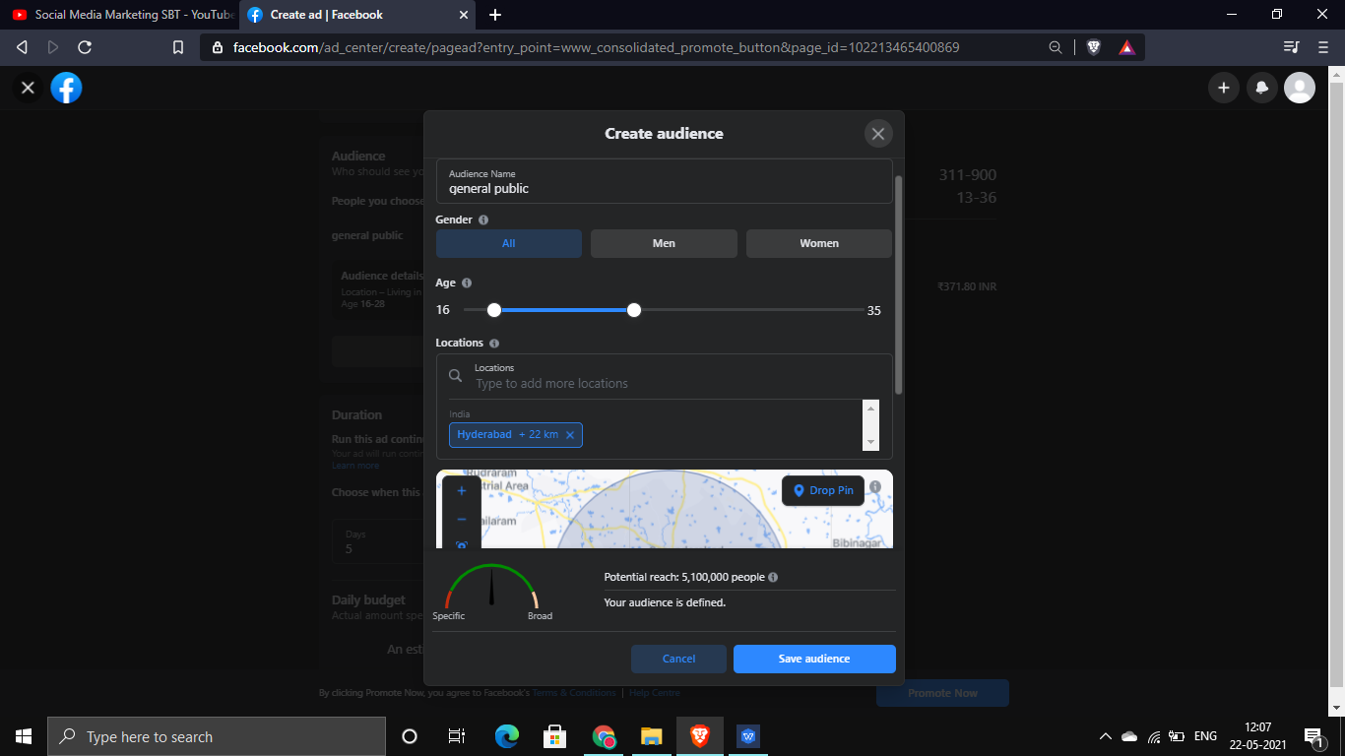

Step 3 b)Detailed targeting: Facebook ads also give us an opportunity to precisely target individuals based upon their demographics, interest, behaviour etc. using this we target even niche markets.

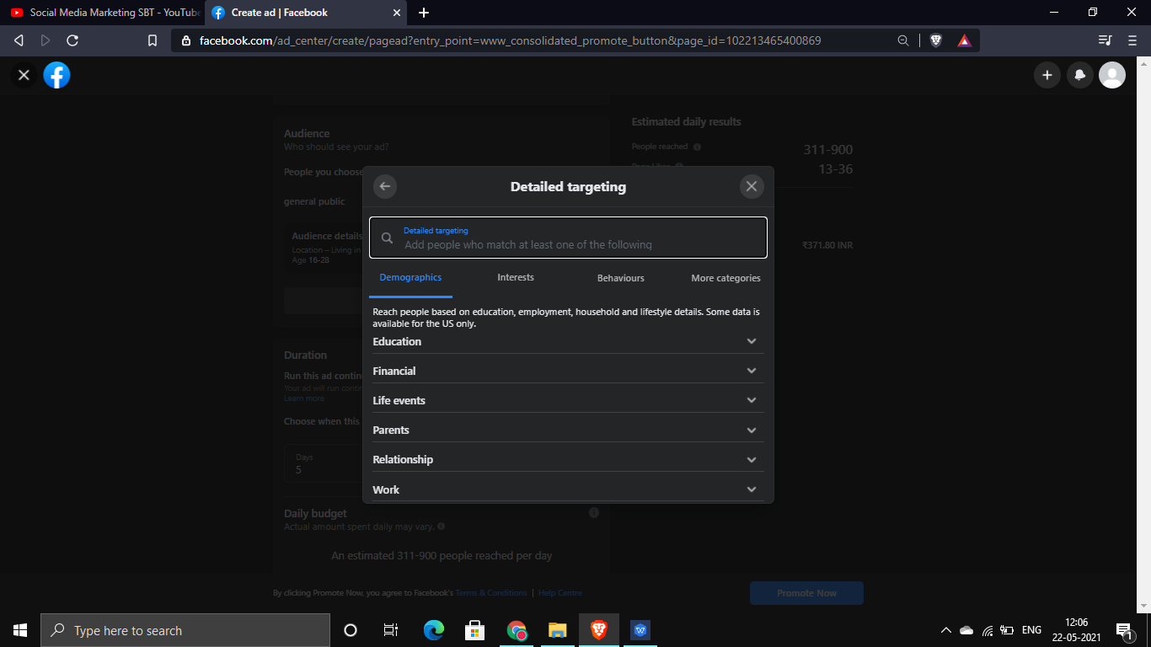

Step 3 b i)Detailed targeting based on demographics

Since a gift shop cant reliably target people based upon their interest and behaviour we will target people mostly on the basis of demographics.

Since a gift shop specialises in birthday gifts and anniversary gifts we are targeting people who have their marriage anniversary within 2 months, people whose friends got recently engaged and people whose friends birthday is coming up.

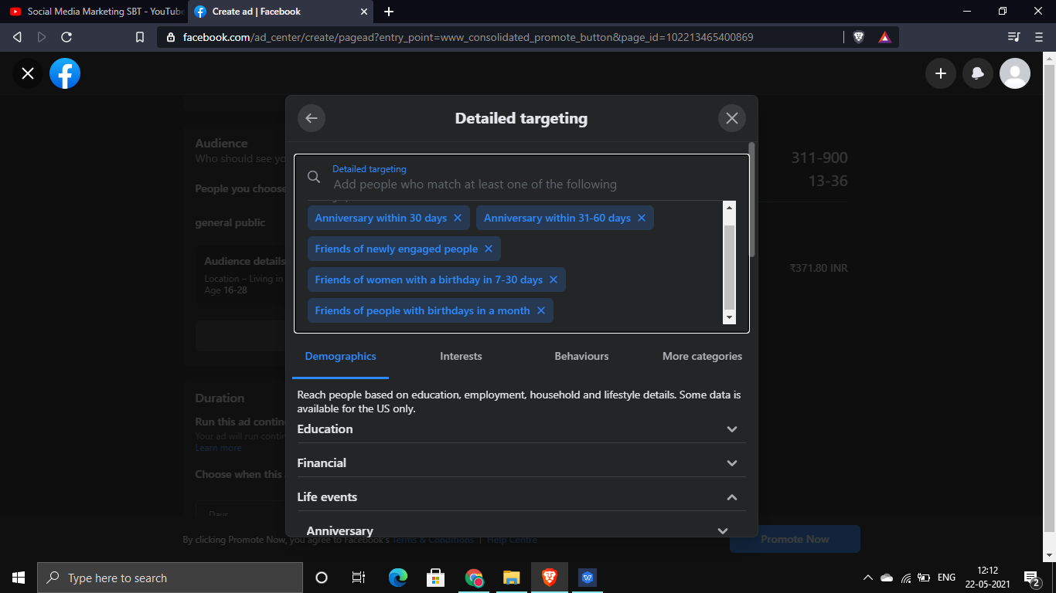

Step 4) Estimated reach and costs

Based upon your targeted audience Facebook calculates the estimated reach of your advert and the number of people who will like/contact your page after seeing the advert. Ads can be run continuously or for a few days. Based upon the estimated reach and the duration of your ad Facebook calculates the cost of your promotion.

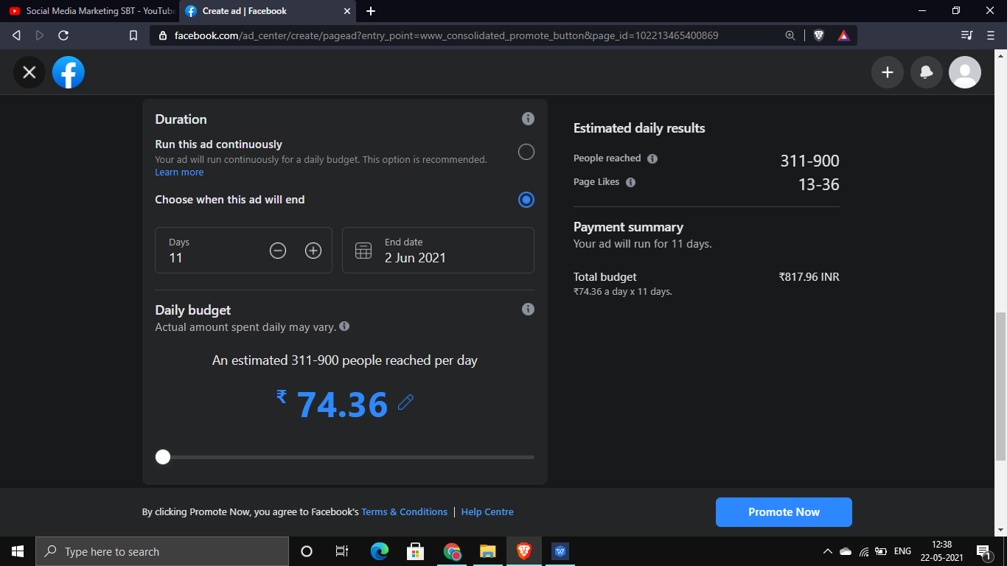

Step 5) Payment:

This is the final step, enter your payment details and click **next** and your advertisement is finally complete.

